**Uncle Grandpa and the number of shortest paths**



Wow, for your information again, the country that Uncle Grandpa is living in consists of $n$ **cities connected by $m$ bi-directional roads**. It's guaranteed that it is possible to travel between any two cities by these $m$ roads. Each road has a specific length (of course right?). Now our Grandpa plans to travel from city $S$ to city $T$, and of course, he wants to choose the shortest path. But more than that, since this is the last problem (what? Why problem here ??? 😄 ???), he wants you to find not only the length of the shortest path from $S$ to $T$ (let’s call that length $W)$ but also the number of different paths from $S$ to $T$ that has the total length equals to $W$.

**Definition:** A path from $S$ to $T$ can be represented as a sequence $S, v_{1}, v_{2},…,v_{x}, T$. So two path $S, v_{1}, v_{2},…,v_{x}, T$ and $S, v_{1}, v_{2},…,v_{y}, T$ will be different $<=>$ the two sequences are different.

## Input

The first line contains four integer $n, m, S, T (1≤n, m≤2*{10}^{5}, 1≤S,T≤n, S≠T)$– the number of cities, the number of bi-directional roads, the start city and the end city.

The next $m$ lines, each will consists three integers $u_{i}, v_{i},w_{i}\left(1≤u_{i}, v_{i}≤n, 1≤w_{i}≤{10}^{9}, u_{i}!=v_{i}\right)$– represent a bi-directional road of length $w_{i}$ connecting city $u_{i}$ and city $v_{i}$.

## Output

Two integers are the length of the shortest path from $S$ to $T$ (let’s call that length $W)$, and the number of different paths from $S$ to $T$ that has the total length equals to $W$. Since the number of paths can be large, please output them modulo ${10}^{9}+7$.

## Examples

|  |  |
| --- | --- |
| Input (countways1.in) | Output (countways2.out) |
| 6 8 1 6  1 2 1  2 3 2  3 6 3  4 1 4  4 5 1  5 6 1  1 3 3  5 1 7 | 6 3 |

## Explanation:

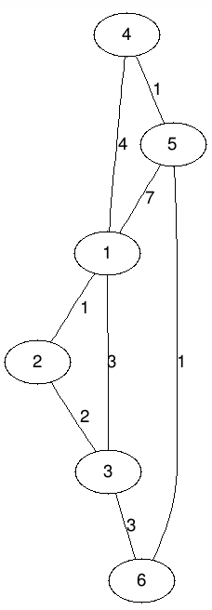For the 1st example, the length of the shortest path from $1$ to $6$ is 6. There are 3 paths from $1$ to $6$ that have a total weight of 6, and they are $1→3→6$, $1→4→5→6$, $1→2→3→6$

## Important note

Since the result can be very large, so you need to output the result’s modulo for ${10}^{9}+7$. To prevent overflow, it’s highly recommended that you take the modulo at every calculation. So for example, instead of $A=B+C$, you should write $A=\left(B+C\right)\%mod$ or instead of $A=B*C$, you should write $A=\left(B*C\right)\%mod$ with $mod={10}^{9}+7$.

## Note:

1. A skeleton file has been given to help you. You should not create a new file or rename the file provided. You should develop your program using this skeleton file.
2. You are free to define your own helper methods and classes (or remove existing ones) if it is suitable but you must put all the new classes, if any, in the same skeleton file provided

## Skeleton File

You can find the skeleton file Countways.java in the lab package.